1. Introduction

RvtUnit is an example of how to achieve Unit Testing within Revit. By running the NUnit runner inside Revit, we can unit test code which relies on the Revit API, without having to wrap the entire Revit API.

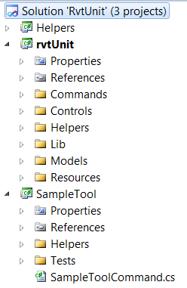The solution contains three projects:

The RvtUnit project is the main project that runs the unit tests.

The SampleTool project shows an example of a Revit IExternalCommand which includes unit tests.

The Helpers project contains some code used by both the other projects. Notably, the RvtUnit project will store a reference to the ActiveUIDocument here, so the unit tests can pick it up

* 1. RvtUnit project
* Designed using the MVVM pattern
* References a custom build of NUnit which has been modified to load DLL’s from a byte array, rather than from disk
* Allows user to select a directory of dll’s, and it will then load them and present a dialog which lets the user run some or all tests
* Contains an ‘AssemblyResolve’ event handler, so that any dependencies of the DLL to be tested, can also be loaded. (Since the Assembly to be tested is loaded from abyte-array, the .Net Framework can’t use it’s normal mechanism)
* The Test runner will not execute the IExternalCommand of any DLL's. It will simply load the DLL, look for any unit tests in the DLL and then run them
  1. SampleTool project
* Contains an example of an IExternalCommand which includes some classes which are unit tested
* The ‘production code’ and the ‘test code’ are compiled into the same dll when the project is compiled in ‘Debug’ mode.  
  The test code is omitted when the project is compiled in ‘Release’ mode. This is achieved by putting test code and references inside an ItemGroup that only compiles for Debug  
    
  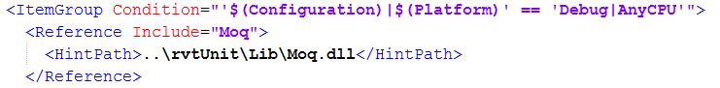
* Contains standard unit tests, and Specflow tests
* The Specflow test also use Moq, although a custom build of both Moq and Castle.Core are required, as the objects must be properly disposed at the end of the test.
* If you run the SampleTool from the Addins menu, it will be loaded from disk and the file locked as per normal. You will then be unable to change, rebuild and reload it.